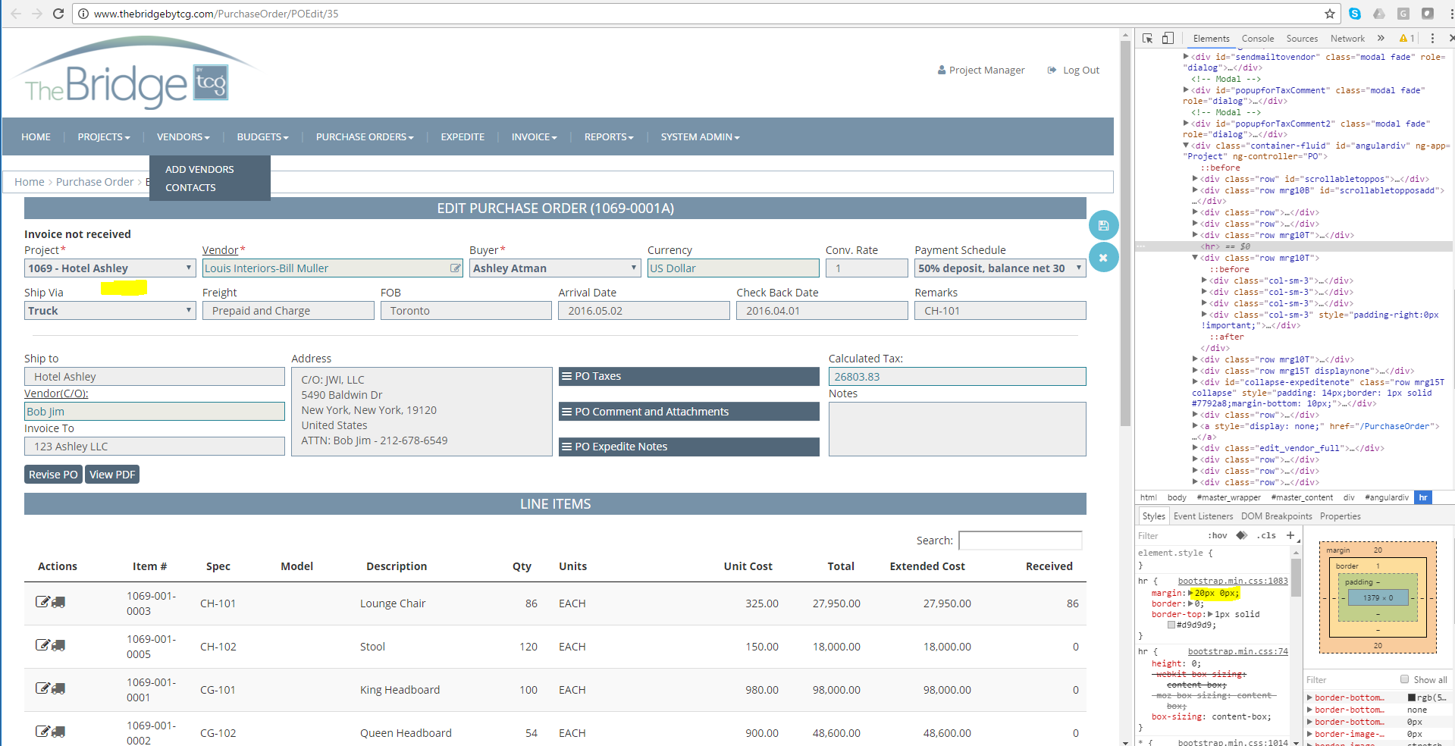

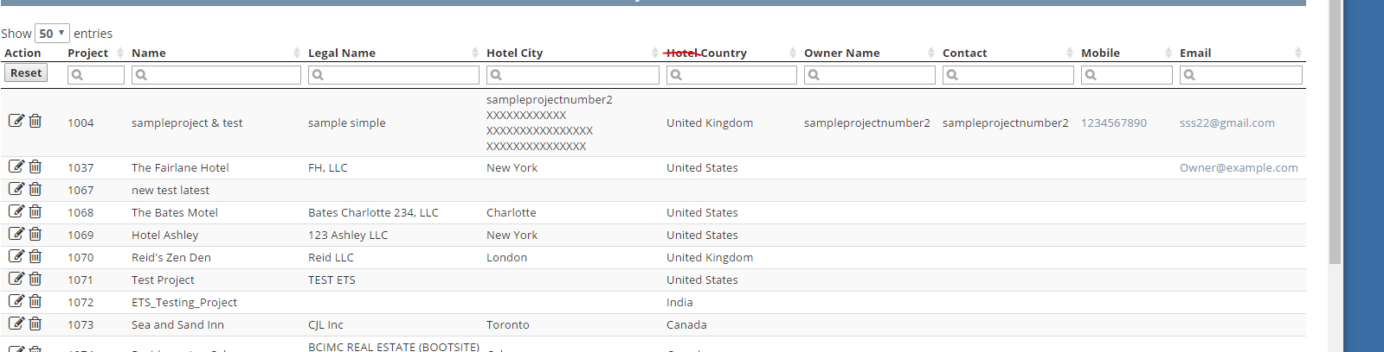

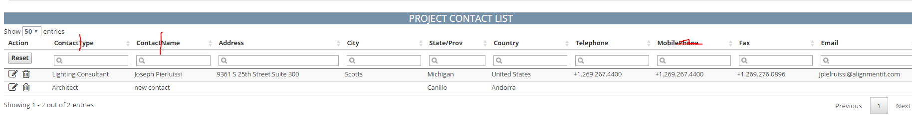

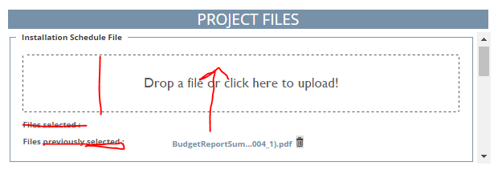
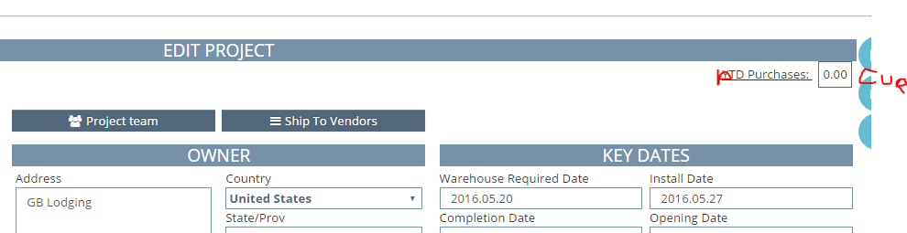

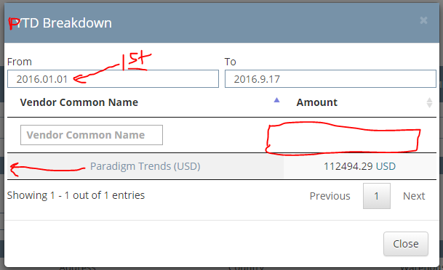
Should be in project currency for all vendors for committed PO’s only

Purchase Order Comments should expand when selected and unexpand when lose focus
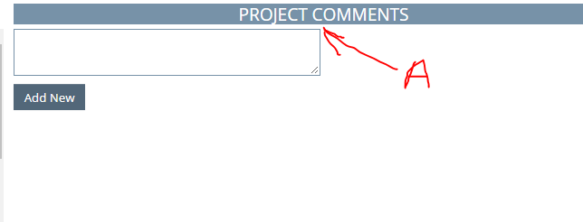
A=Enter Comment

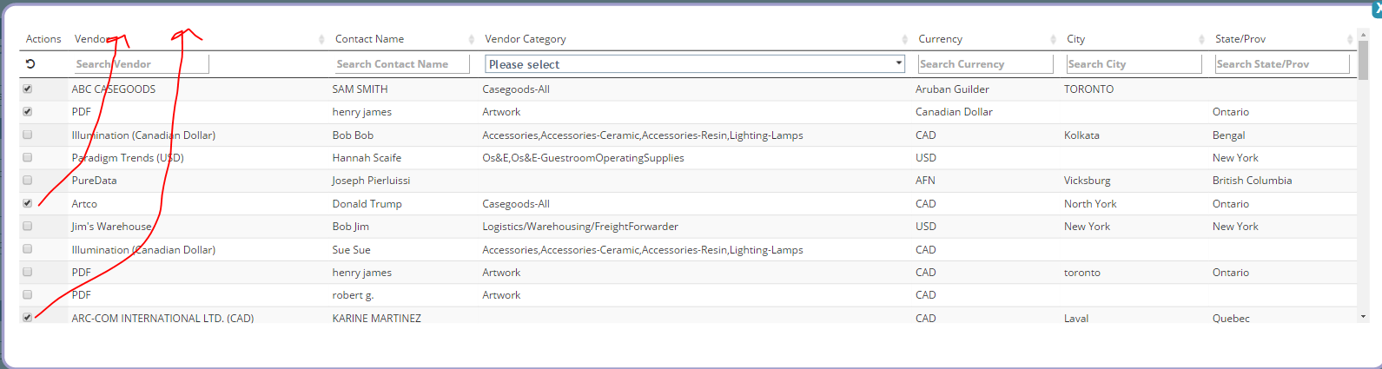Percolate selected items to the top
Project contact apply standards

On the add member screen, configure the same as add user.

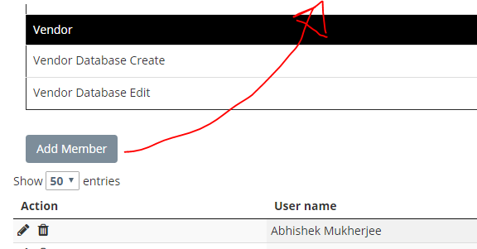
Make this a round blue button

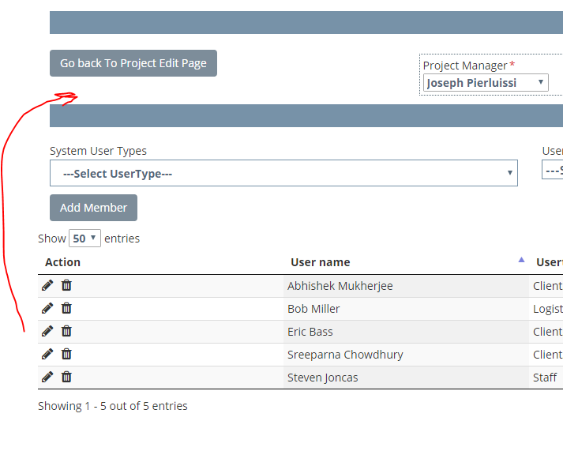

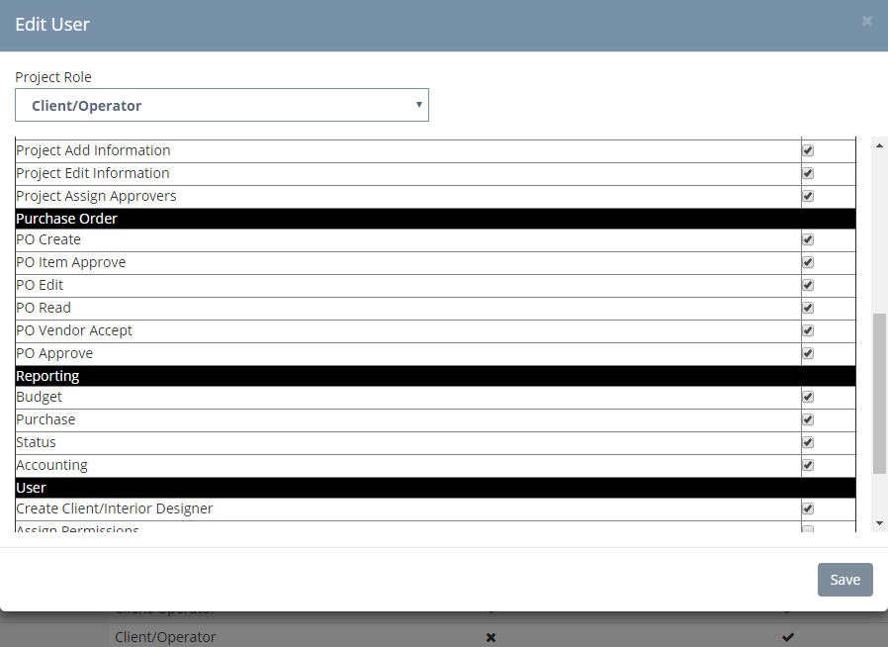Remove Project, User and vendor. Use add user format for this window. The same is true for the other user edit screen
Propagate all table headings freeze
PO Line Items needs balancing

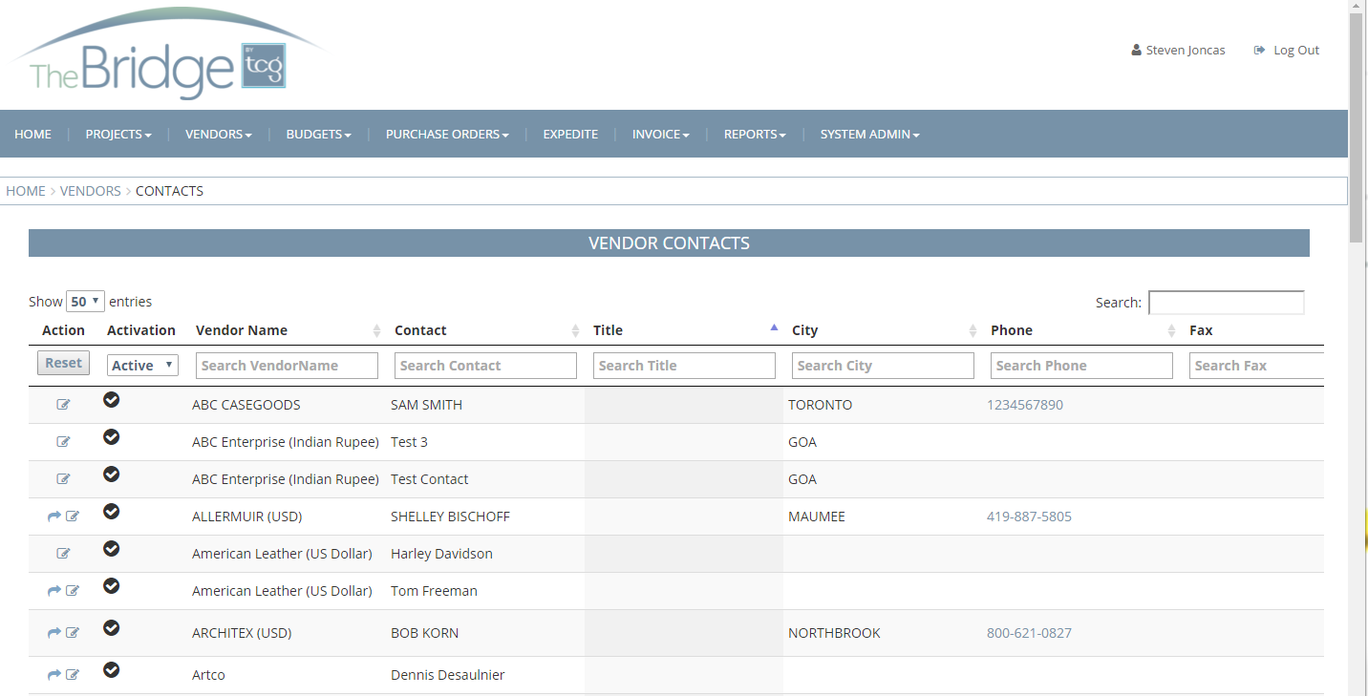

Font too big
Add link to contact name to edit contact
Limit list to 20 contacts
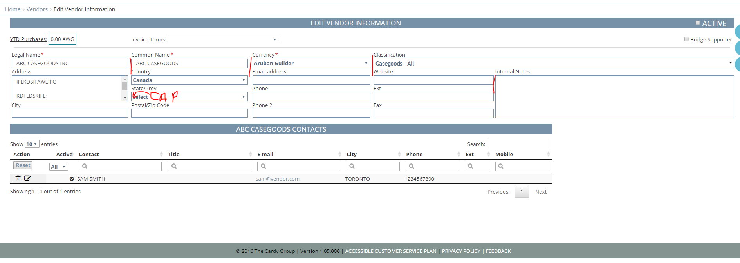

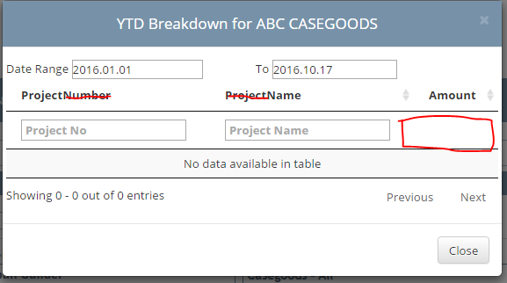
Show in vendor currency with filtered amount confirm YTD amount
On vendor default to active
When adding a contact, they are not active until they activate after receiving e-mail. At that point Vendor is active.
Remove active check mark from vendor header
If vendor checkmark is inactive
Message that contact must be added needs to stay longer
Permissions should only show for system users

Edit contact screen clean-up
Add vendor name to contact header
Should be able to toggle contacts from vendor edit screen
Add title to contact edit screen
Add hidden column to contact lists. Default contact list to active and inactive (All). Only show for system users.

When adding a vendor YTD purchases were linked to Residence INN

